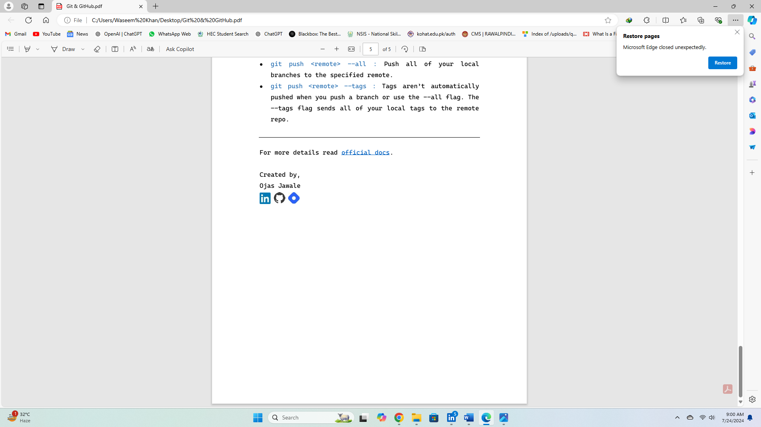

**Waseem Khan**

Linux

Basics (02)

file commands

1.Command to Create a file:

* touch [File Name]

**Exp:**

* touch noormast
* touch Document1

2.Command to list the files:

This command will only list the files and their name.

* ls

3.Command to list the files and their date of creation:

* ll

Note: Servers will not follow Pakistani time zone.

4.Command use to show the content in the file:

* cat [file name]

**Exp:**

* cat noormast

5.Command to insert content in a file:

* cat>>noormast

6.command to save/Enter the content in file:

* Enter (enter from Keyboard only)

7. Command to exit the file:

* ctrl + d

8.Command to copy files from file to another file:

First method is that we have already created file. For example, file1(noormast) and file2(Document1) then we have to write the command.

* cp [file1 name] [file2 name]

**Exp:**

* cp noormast Document1

The second method involves having only one file containing the data, with no other files present. In this case, you can copy the contents of the existing file to a new file using a command in Linux. Here is the command to achieve this

* cp [Existing file1/file2 name] [any name for new file (choose name for the file to which you will copy data)]

**Exp:**

* cp noormast neeeewfile

9.Command used to rename a file:

* mv filename1 [new name]

**Exp:**

* mv noormast sayem

10.command use to remove a file:

* rm [file name]

Used to remove a file but not forcefully it will ask user if he want to remove the file or not.

* rm [file name] -f

Used to remove forcefully and no yes or no option will be shown.

* rm *

Used to remove all files.

* rm * -f

Used to remove all file forcefully.

11.Command used to create more files:

* touch file {1.100}

User can enter any number of files need to created instead of 100.

12.Command use to copy from file to another without deleting data from file1 as in previous option (command 8) when we copy it delete data from parent file:

* cat file1>>file2

13.commmand use to show the 1st ten lines written in a file:

* head [file name]

**Exp:**

* head noormast

How can we specify number of head lines to show??

14.command used to show specific number of head lines in a file:

* head –[Enter number of lines] [file name]

**Exp:**

* head -5 noormast

15.Command use to show the last ten lines in a file:

* tail [file name]

**Exp:**

* tail noormast

How can we specify number of Tail lines to show??

16.command use to show specific number of tail lines in a file:

* tail –[number of lines] [file name]

**Exp:**

* tail -5 noormast

Basically, we use the head and tail command to show in real time for logs etc. to see the activity

17.Command use to show middle lines in file:

* sed -n ‘[Starting line number], [ending line number]’ [file name]

**Exp:**

* sed -n ‘5,15p’ noormast

18.Command use to count lines, words then characters!

* wc [file name]

**Exp:**

* wc noormast

Troubleshot Technique

What you will do! if your server is slow or Crash?

Answer:

1.Check Server Performance! How?

command used to check server performance!

* top
* yum install htop -y

Used to check server perfomance such cpu utilization and ram usage.

Note: We have a ‘htop’ but that need a package that why we not use it not. we will learn that later.

We Will learn extra troubleshooting method with a time.

**Created By,**

**Waseem Khan**